Consider function 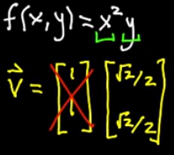 and a vector v (normalized)

Directional derivative at a specified point, say (-1, -1) is given by the formula 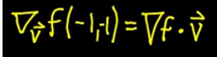

Gradient is computed using the formula 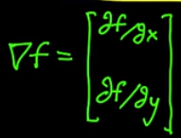. For the given function, the gradient at (-1, -1) is 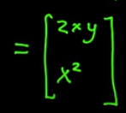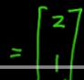

Now, substituting in the second equation above, we get the directional derivative as 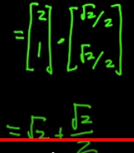

For more details, watch <https://www.youtube.com/watch?v=4tdyIGIEtNU>

Multi-variable chain rule for differentiation

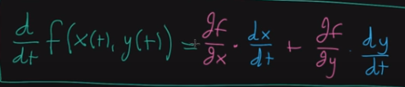

Watch the details at <https://www.youtube.com/watch?v=NO3AqAaAE6o>